

13 July 2022

**Terra Industrial New Zealand Ltd**

PO Box 16 168

16 Branston Street, Hornby

Christchurch 8441, New Zealand

03 983 2333 Tel

www.TerraCat.co.nz

**MDM Enrollment iOS**

1. Open the Safari browser on your iPhone or Apple device. (Must be Safari, not Chrome etc.)

1. Enter into the address bar **mdm.ggh.co.nz/enroll/user**

1. You will be brought to this page, click the ‘**Have a group ID?’** button.

1. Previous step will bring up the **Group ID** field beneath the Email Address field. Enter your **@terracat.co.nz** email address and the Group ID **GGH** and click **Next.**

1. You will get the following pop up, click **Allow**, and the profile will begin to download. Close the popup and click **Continue**.

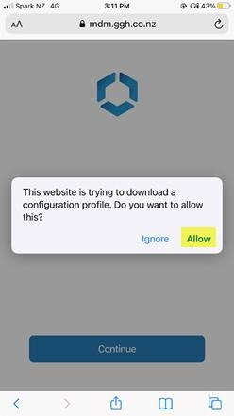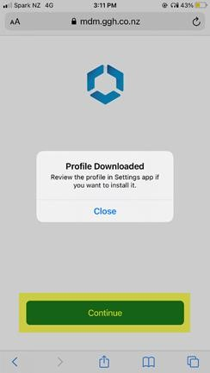

1. Follow the steps that will display on screen and navigate to the **Settings** app. Click through to the **Enrol in** highlighted below.

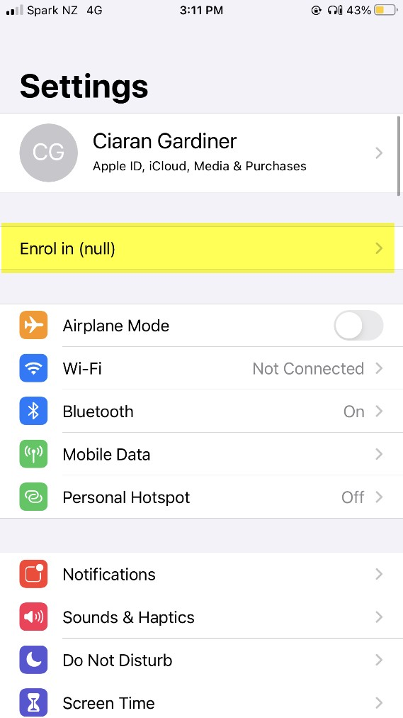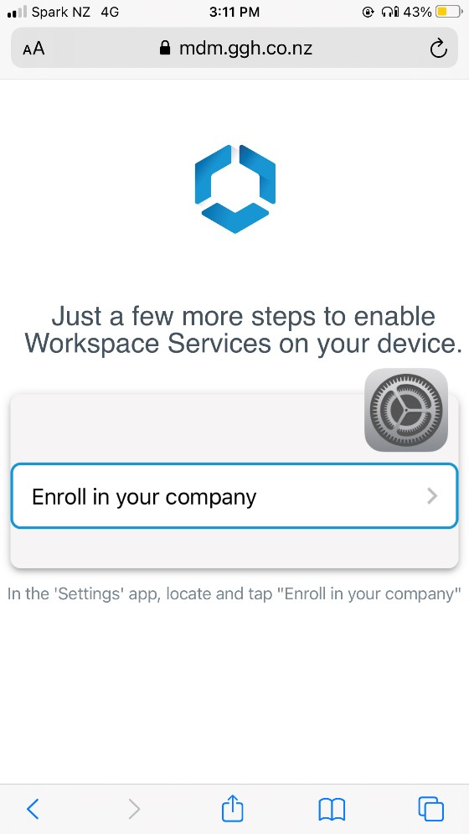

1. Click the **Enrol My iPhone** button, then enter your phone passcode to continue.

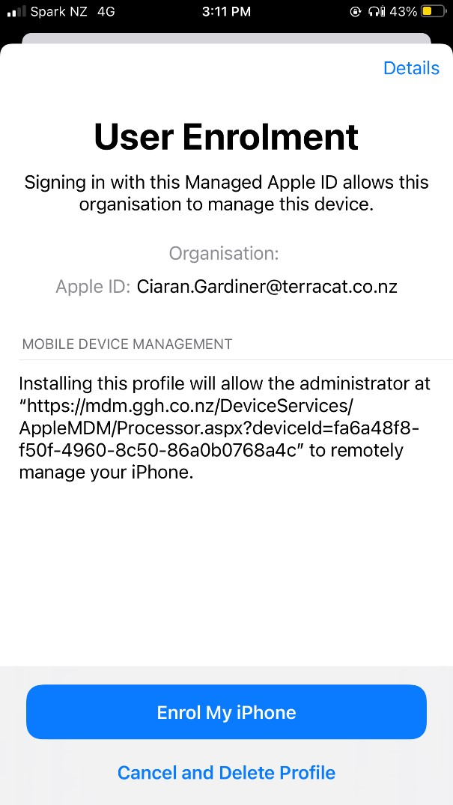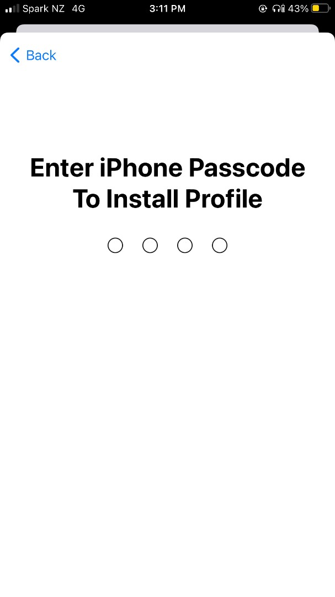

1. An Apple ID will be generated using your email address for the MDM Profile, click **Continue** when available.

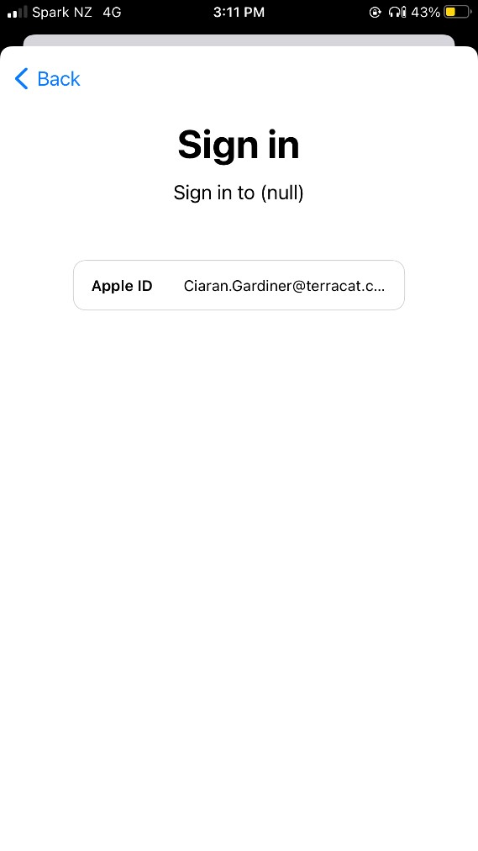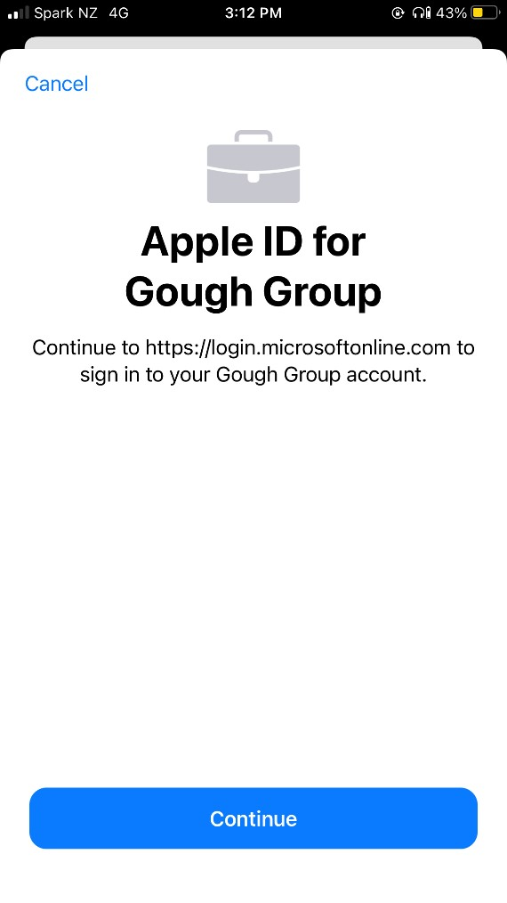

1. Once again, sign in using your **@terracat.co.nz** email address and your account password after hitting **Next.** Click **Yes** on the stay signed into Microsoft page.

1. From here the profile should be installed and you may be forced to change your current passcode.